**1D Array:-**

**Output:-**

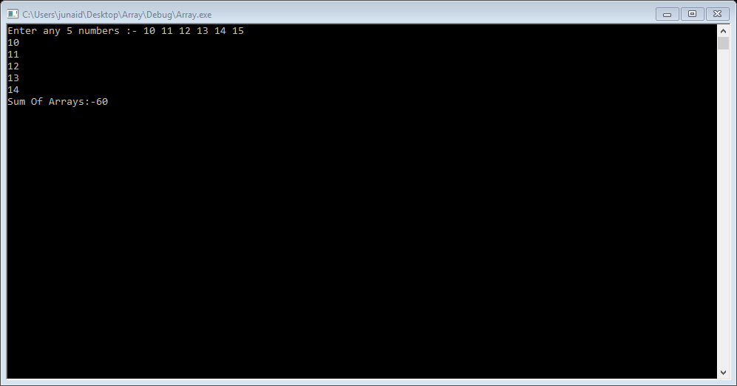

**Coding:-**

#include<iostream>

#include<conio.h>

#include<stdio.h>

using namespace std;

void main()

{

int a[5], sum = 0;

cout << "Enter any 5 numbers :- ";

for (int i = 0; i < 5; i++)

{

cin >> a[i];

}

for (int j = 0; j < 5; j++)

{

cout << a[j] << endl;

sum = sum + a[j];

}

cout << "Sum Of Arrays:-" << sum << endl;

_getch();

}